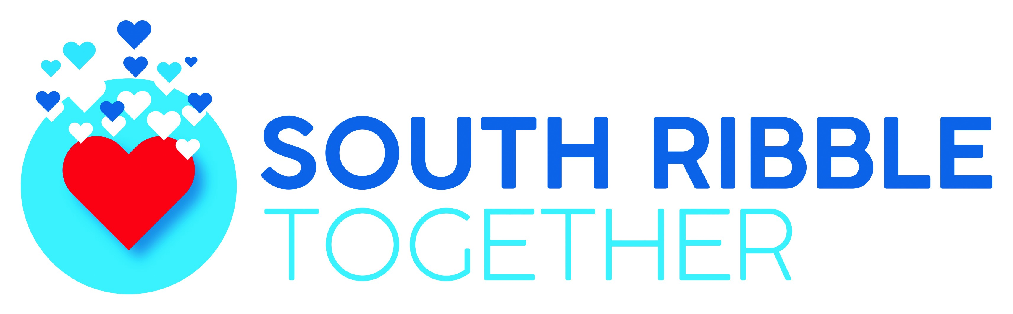
Local Professionals Survey - Impact of COVID-19 on Mental Health

- In your experience, has COVID-19 had an impact on the mental health of your service users?

Yes No

- Have you seen an increase in demand based on people’s mental health suffering?

Yes No

- Have service needs become more complex as a result of COVID-19 affecting mental health?

Yes No

- For your service users who were already diagnosed with mental health conditions, which of the following would you say have worsened during the pandemic?

Depression |  | Isolation / loneliness
Anxiety |  | Psychosis
Paranoia |  | Other

- For your service users who were already diagnosed with mental health conditions, which of the following would you say have worsened during the pandemic?

Depression |  | Isolation / loneliness
Anxiety |  | Psychosis
Paranoia |  | Other

- If you have service users living with dementia or other memory related conditions, what impact would you say that COVID-19 has had?

No impact
Some adverse impact
Significant adverse impact
Unsure / Not applicable

- Have you seen an increase in substance misuse during the pandemic?

No – nothing has changed
Yes – increased alcohol consumption
Yes – increased use of prescribed medication
Yes – increased use of recreational drugs
Unsure / Not applicable
Other (please specify)

- Have you seen an increase in reports of domestic abuse during the pandemic?

No – nothing has changed
Yes – increased reports of domestic violence
Yes – increased reports of emotional abuse
Yes – increased reports of sexual abuse
Yes – increased reports of financial abuse
Yes – increased reports of coercive control
Other (please specify)

- If you have any other feedback about the impact of COVID-19 on mental health, please share it with us:

